Robotics Workspace Layout
A Project Report related to Course “Computer Aided Engineering Graphics” submitted to Mallareddy Engineering College for Women, Hyderabad, in partial fulfillment for the award of Degree of
B. Tech in

CSE-DATA SCIENCE
By
P SRINIDHI 26RH1A67Q3
P SRI VIDYA 26RH1A67Q4
P SHRUTHI 26RH1A67Q5

Under the supervision of Mr. Charan Budavati Dr.K Vijayasree



Department of Mechanical Engineering (H&S) MALLAREDDY ENGINEERING COLLEGE FOR WOMEN
(Autonomous Institution-UGC, Govt. of India) Accredited by NBA and NAAC with ‘A⁺’ Grade
National Ranking by NIRF-Rank band (151-300), MHRD, GOVT. of India Affiliated to JNTUH, Approved by AICTE, ISO 9001:2015 Certified Institution Maisammaguda, Dhulapally, Secunderabad-500100

October, 2026

MALLAREDDY ENGINEERING COLLEGE FOR WOMEN
(Autonomous Institution-UGC, Govt. of India) Accredited by NBA and NAAC with ‘A⁺’ Grade
National Ranking by NIRF-Rank band (151-300), MHRD, GOVT. of India
Affiliated to JNTUH, Approved by AICTE, ISO 9001:2015 Certified Institution
Maisammaguda, Dhulapally, Secunderabad-500100

CERTIFICATE

This is to certify that the Project Report related to Course “Computer Aided Engineering Graphics” titled Robotics Workspace Layout submitted by
P SRINIDHI 26RH1A67Q3 P SRI VIDYA 26RH1A67Q4 P SHRUTHI 26RH1A67Q5
of B. Tech I Year I Semester graduates to the Mallareddy Engineering College for Women, Hyderabad, in partial fulfillment for the award of the degree of Bachelor of Technology in CSE-DATA SCIENCE is a bonafide record of the project work carried out by them under my/our supervision. The contents of this report, in full or in parts, have not been submitted to any other Institution or University for the award of any degree or diploma.

<Signature> <Signature>

Dr. K. Vijayasree Mr. Charan Budavati

DECLARATION

We declare that this Project Report related to Course “Computer Aided Engineering Graphics” titled Robotics Workspace Layout submitted in partial fulfillment of the degree of Bachelor of Technology in CSE-DATA SCIENCE is a record of original work carried out by me under the supervision of Mr. Charan Budavati and Dr.
K. Vijayasree , and has not formed the basis for the award of any other degree or diploma, in this or any other Institution or University. In keeping with the ethical practice in reporting scientific information, due acknowledgements have been made wherever the findings of others have been cited.

<Signature>

P SHRUTHI 26RH1A67Q5

<Signature> <Signature>

P SRI VIDYA P SRINIDHI
26RH1A67Q4 26RH1A67Q3

ACKNOWLEDGEMENT
We feel ourself honored and privileged to place our warm salutation to our beloved Principal, Dr. Y. Madhavee Latha who gave us the opportunity to have experience in engineering and profound technical knowledge.
We express our heartiest thanks to our Head of the Department, Dr. A. Swaroopa Rani,
for encouraging us in every aspect and helping us realize our full potential.

We would like to thank our supervisors Mr. Charan Budavati and Dr. K. Vijayasree and Course Head Dr. S. Naresh Kumar Reddy for their guidance, encouragement. We are extremely grateful for their valuable suggestions and unflinching cooperation during preparation of project.
We would also like to thank our Class In-charges Ms.NagaLakshmi supporting staff who have been helping directly or indirectly in making a successful project report.
We extremely grateful to our Parents for their blessings and prayers for the completion of our project report that gave us strength to do.

TABLE OF CONTENTS

Chapter No | Description | Page No
 | Cover Page | i
 | Certificate | ii
 | Declaration | iii
 | Acknowledgement | iv
 | Abstract | v
 | List of Figures | vi
 | List of Tables | vii
 | Abbreviations/ Notations/ Nomenclature | viii
I | Introduction | 1
II | Literature Review | 2
III | Methodology | 3
IV | Implementation & Results | 4-5
V | Conclusion & Future Scope | 6
 | References | 7

Abstract

Robotics Workspace Layout is an important concept in modern industries that focuses on the proper planning and arrangement of robots, machines, tools, and other equipment in a working area. The main aim of this project is to design a well-organized, efficient, and safe workspace where robots can perform different tasks smoothly. Nowadays, robots are widely used in manufacturing industries, automobile factories, warehouses, healthcare centers, and many other fields to reduce human effort and improve the quality of work. A properly designed robotics workspace helps robots move easily, perform tasks accurately, and complete operations within less time. It also helps make the best use of available space and prevents unnecessary movement of robots and workers In a robotics workspace, different components such as robotic arms, sensors, conveyor belts, workstations, control systems, and safety equipment must be placed in suitable positions. Proper arrangement of these components helps robots perform activities such as picking and placing objects, assembling products, welding, packaging, and material handling. While designing the workspace, important factors such as the size of the working area, robot movement, accessibility, lighting, power supply, and safety measures must be considered. A good workspace layout also reduces the chances of collisions between robots, machines, and workers. It helps improve the speed, accuracy, and overall performance of robotic systems.The main objective of this project is to understand how an effective robotics workspace layout can improve industrial operations and make work easier and more productive. It also focuses on reducing wasted space, saving time, minimizing errors, and maintaining a safe working environment. By using a suitable layout, industries can increase productivity, reduce operational costs, and improve the quality of their products. In conclusion, Robotics Workspace Layout plays an important role in the development of smart factories and automated industries. A well-planned workspace allows robots and humans to work more efficiently and safely, making industrial processes faster, more reliable, and better organized.

List of Figures:
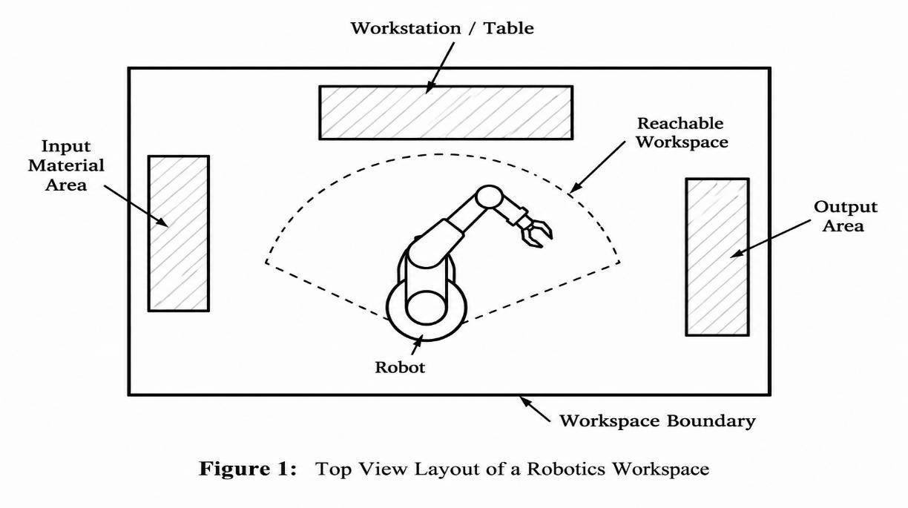

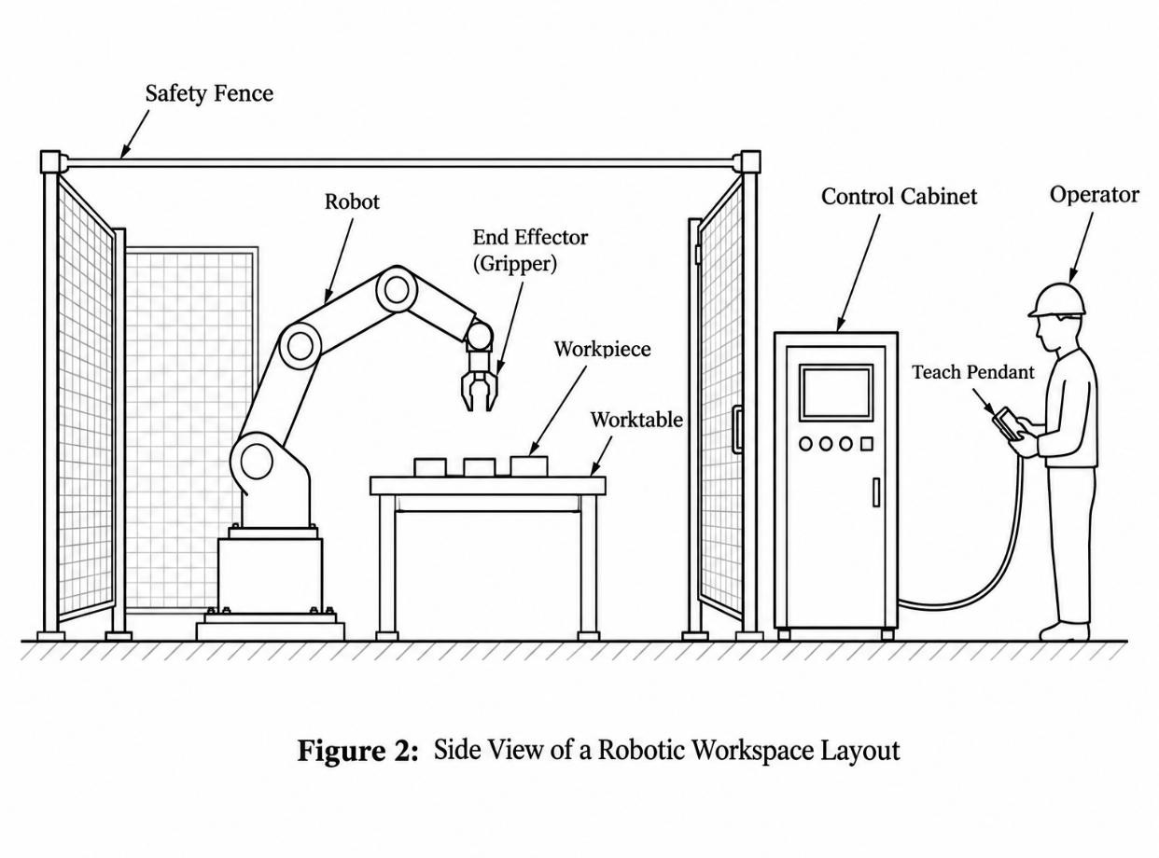

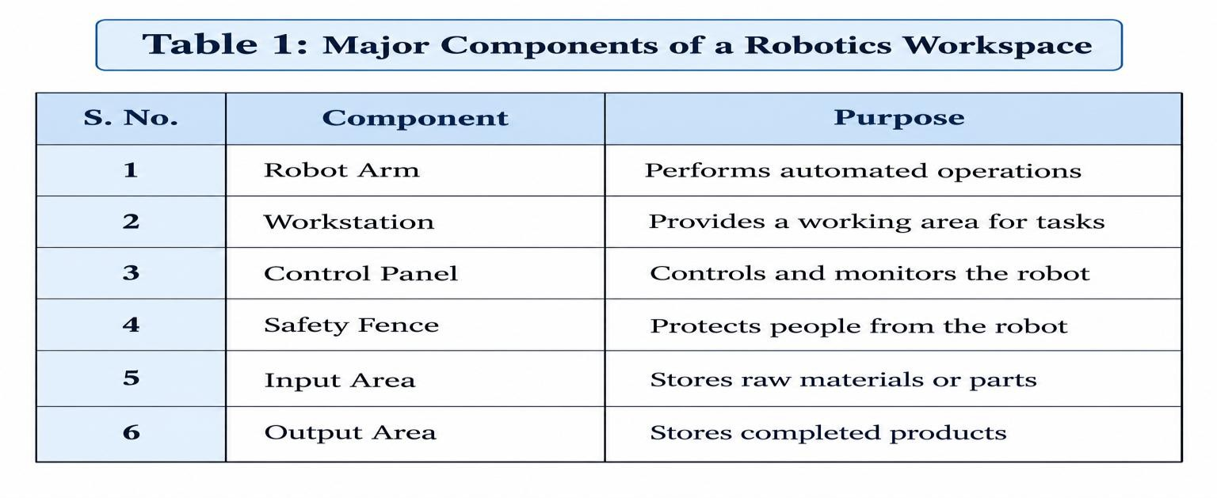
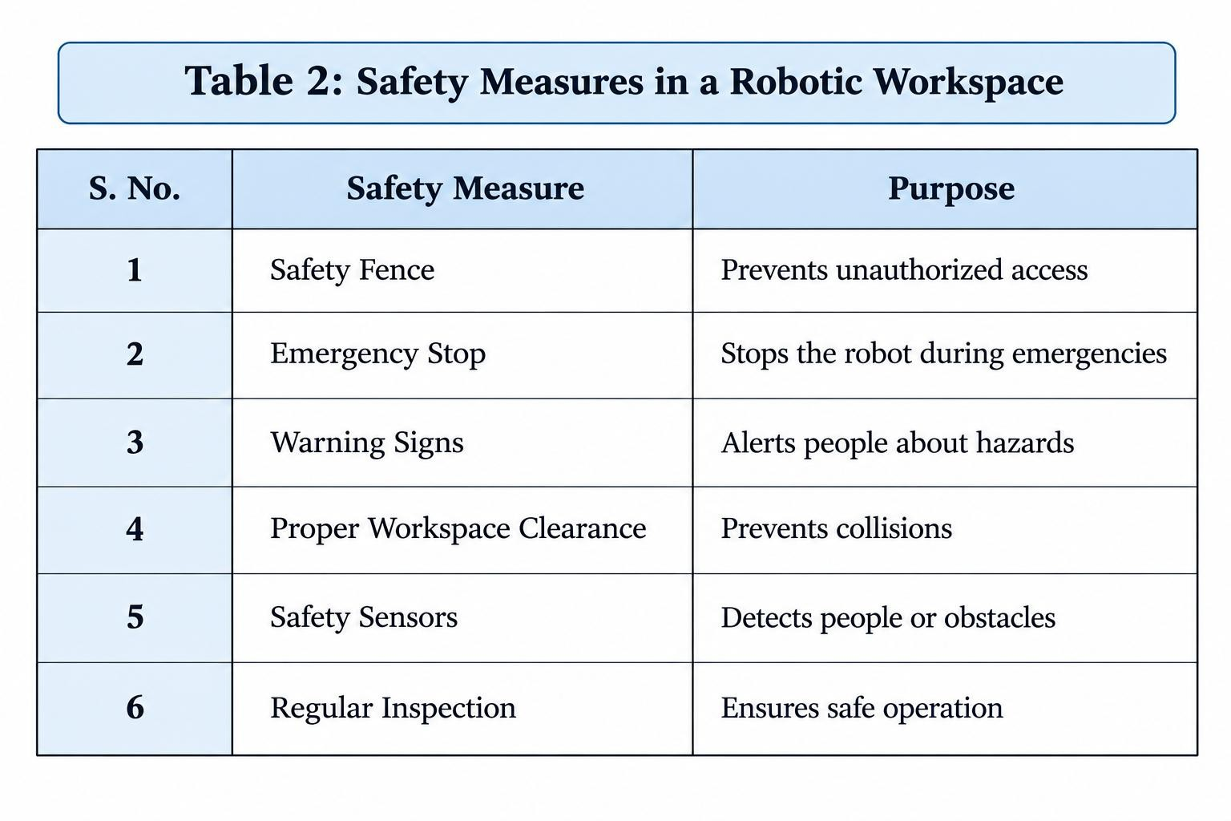
List of Tables:

Abbreviations/ Notations/ Nomenclature
In a robotics workspace, several abbreviations and technical notations are used to describe the different components, systems, and safety features. These terms make the project easier to understand and provide a standard way of referring to important elements of the robotic workspace.

RWS (Robotic Workspace) refers to the designated area in which a robot performs its assigned operations. RA (Robot Arm) represents the mechanical arm that carries out automated movements such as picking, placing, assembling, and handling objects. WP (Workpiece) refers to the material or component that is processed or handled by the robot.

CP (Control Panel) is the interface used to operate, monitor, and control the robotic system. SF (Safety Fence) is a protective barrier provided around the robotic operating area to reduce the risk of accidental contact. WS (Workstation) represents the area where the robot, worktable, tools, materials, and other equipment are arranged for carrying out the required task.

Other important terms include E-STOP (Emergency Stop), which is used to stop the robot quickly during an emergency; HMI (Human–Machine Interface), which allows an operator to interact with the robotic system; and PLC (Programmable Logic Controller), which controls and coordinates automated industrial processes.

EOAT (End-of-Arm Tooling) refers to the tool attached to the end of the robot arm, such as a gripper or welding tool. SOP (Standard Operating Procedure) refers to the documented instructions used for safe and proper operation of the robotic workspace. These abbreviations and notations help in describing the workspace layout clearly and systematically.

Introduction

Robotics is an important field of modern engineering that combines mechanical systems, electronics, computer technology, and automation to perform tasks with high accuracy and efficiency. Robots are widely used in industries such as manufacturing, automobile production, electronics, packaging, material handling, and assembly. As the use of robots increases, proper planning of the workspace becomes essential for achieving safe and efficient operation.

A Robotics Workspace Layout refers to the systematic arrangement of the robot, workstation, control panel, safety equipment, input and output areas, tools, and other supporting facilities within a designated area. A well-designed workspace ensures that the robot has sufficient space to perform its required movements while reducing unnecessary motion, interference, and the possibility of accidents.

The layout of a robotic workspace should consider factors such as robot reach, workpiece movement, operator access, equipment placement, safety zones, emergency stops, and maintenance requirements. Proper positioning of these components can improve productivity, reduce downtime, and make the working environment safer for operators and maintenance personnel.

This project focuses on understanding the basic principles of robotics workspace layout and designing a suitable arrangement of robotic equipment. It also considers safety requirements and efficient utilization of available space. The proposed layout helps demonstrate how different components can be organized to create a practical, safe, and efficient robotic working environment.

Literature Review

The design of a robotics workspace has been studied extensively because the arrangement of robots, equipment, materials, and operators directly affects productivity, safety, and efficiency. Researchers and industrial engineers have focused on developing workspace layouts that provide sufficient robot movement while minimizing unnecessary motion and operational Traditional robotic workspace layouts mainly concentrated on the reachability and movement of the robot arm. The workspace is generally defined according to the robot's maximum and minimum reach. Proper positioning of the robot and workpiece allows the robot to complete tasks without excessive movement. This can reduce cycle time and improve overall productivity.

Safety is another major consideration in robotic workspace design. Modern layouts commonly include safety fences, emergency-stop systems, sensors, warning indicators, and restricted operating zones. These features help separate personnel from hazardous robot movements and reduce the possibility of accidents. Safety standards and risk-assessment methods are therefore important during the planning and installation of robotic systems.Studies on human–robot interaction have also influenced workspace design. In many modern manufacturing environments, robots and human operators work in nearby areas or collaborate on different stages of production. Consequently, workspace layouts need to provide adequate clearance, visibility, access, and safe zones for operators while allowing the robot to perform its tasks efficiently.

Recent developments in robotics have encouraged the use of simulation and computer-aided design (CAD) for workspace planning. Digital models can be used to study robot reach, possible collisions, movement paths, and equipment placement before the physical workspace is constructed. This approach can reduce design errors and allow different layouts to be compared efficiently.Overall, the literature indicates that an effective robotics workspace should balance robot reachability, safety, productivity, accessibility, material flow, and space utilization. These principles form the foundation for developing a suitable workspace layout for the present project.

Methodology
The methodology for designing a robotics workspace layout begins with identifying the requirements of the robotic system and the tasks it needs to perform. The available floor area, robot dimensions, working range, workstation position, material flow, operator access, and safety requirements are considered during the planning stage.

First, the major components such as the robot arm, workstation, control panel, safety fence, input area, output area, and emergency-stop system are identified. The robot's reach and movement range are then analyzed to determine the appropriate position of the robot and other equipment.

Next, the workspace is divided into suitable operating and safety zones. The input and output areas are positioned to provide a smooth material flow and reduce unnecessary movement. Safety barriers and sufficient clearance are provided around the robot to protect operators and maintenance personnel.

Finally, the proposed layout is evaluated based on space utilization, accessibility, safety, robot movement, and operational efficiency. The final arrangement is selected to provide a practical and organized robotic workspace.

- Workspace Planning: Identify the robot, workstation, control panel, input/output areas, and available workspace dimensions.

- Layout Design: Arrange the components according to robot reach, material flow, operator access, and safety requirements.

- Evaluation: Analyze the final layout for safety, efficient space utilization, easy accessibility, and smooth robot operation.

Implementation and Results Implementation:
The proposed robotics workspace layout was implemented by arranging the robot arm, workstation, control panel, input area, output area, and safety fence in suitable positions. The robot was placed so that it could reach the required working area without unnecessary movement. The input and output areas were positioned to provide smooth material flow during operation.The safety fence and clearance zones were incorporated around the robot to provide protection to operators and maintenance personnel. The control panel was positioned at an accessible location for easy monitoring and operation.The implemented layout resulted in better utilization of workspace, improved material flow, easier access to equipment, reduced unnecessary robot movement, and enhanced safety. The arrangement also provides a systematic and organized working environment for robotic operations.

- Workspace Preparation: The available workspace was analyzed and divided into suitable operating, material, and safety areas.

- Robot Placement: The robot arm was positioned to provide sufficient reach and movement for the required operations.

- Workstation Arrangement: The workstation was placed within the robot's working range for easy handling of workpieces.

- Control Panel Placement: The control panel was located at an accessible position for monitoring and controlling the robot.

- Space Utilization: Equipment was arranged systematically to minimize unused space and avoid unnecessary obstruction.

- Layout Evaluation: The proposed arrangement was evaluated based on robot movement, safety, accessibility, and material handling.

Results:

The implementation of the proposed Robotics Workspace Layout produced a systematic and functional arrangement of the major robotic components. The robot arm was positioned in a suitable location so that its working range covered the required workstation without unnecessary movement. This arrangement supports smooth and efficient robotic operations.

The workstation was placed within the robot's reachable area, allowing workpieces to be handled effectively. The input and output areas were organized to maintain a proper flow of materials through the workspace. This helps reduce unnecessary movement and improves the overall efficiency of the operation.The control panel was positioned at an easily accessible location for monitoring and controlling the robotic system. Safety fences and sufficient clearance were provided around the robot to separate the operating area from the operator area and reduce potential safety risks.

The final layout also improved the utilization of the available floor space. Proper positioning of the equipment provided sufficient access for operation, inspection, and maintenance activities. The organized arrangement reduced congestion and made the workspace easier to understand and manage.

Overall, the results show that a properly planned robotics workspace can provide better safety, efficient space utilization, smooth material flow, easy accessibility, reduced unnecessary movement, and improved operational efficiency. The proposed layout therefore provides a practical foundation for designing a safe and effective robotic working environment.

Conclusion &Future Scope

Conclusion

The Robotics Workspace Layout project demonstrates the importance of proper planning and organization of a robotic working environment. The layout was designed by considering the robot's working range, workstation position, material flow, operator accessibility, safety requirements, and available floor space.The proposed arrangement provides a systematic placement of the robot arm, workstation, control panel, input and output areas, and safety barriers. Proper positioning of these components helps reduce unnecessary movement, improve space utilization, and provide a safer working environment.

The project shows that an effective workspace layout can improve productivity, safety, accessibility, material handling, and overall operational efficiency. Therefore, proper workspace planning is an important part of successful robotic system implementation.

Future Scope

- Advanced Simulation: Robot simulation software can be used to test different workspace layouts before physical implementation.
- CAD-Based Design: 3D CAD models can be developed to obtain more accurate dimensions and equipment placement.
- Automatic Safety Systems: Sensors, cameras, and automatic emergency systems can be incorporated to improve workspace safety.
- Collaborative Robots: Future layouts can include collaborative robots that can safely work alongside human operators.
- Smart Monitoring: IoT and real-time monitoring systems can be used to track robot performance and workspace conditions.
- Layout Optimization: Artificial intelligence and optimization techniques can be applied to improve robot movement, material flow, and space utilization.

References
  - ISO 10218-1:2025, Robotics — Safety Requirements — Part 1: Industrial Robots. International Organization for Standardization. ISO
  - ISO 10218-2:2025, Robotics — Safety Requirements — Part 2: Industrial Robot Applications and Robot Cells. International Organization for Standardization. ISO
  - Siciliano, B. and Khatib, O., Springer Handbook of Robotics, Springer.
  - Groover, M. P., Automation, Production Systems, and Computer-Integrated Manufacturing, Pearson.
  - Craig, J. J., Introduction to Robotics: Mechanics and Control, Pearson.
  - ISO 6385:2016, Ergonomics Principles in the Design of Work Systems. GSO Sims Preview Document
  - European Agency for Safety and Health at Work, Collaborating Robots – Safety and Technical Requirements. oshwiki.osha.europa.eu

